**Dedicating node in Jenkins:**

1. Go to “Manage Jenkins -> Manage nodes and clouds”
2. Click on your node
3. Click on Configure
4. Select Usage to “Only build jobs with label expressions matching this node”

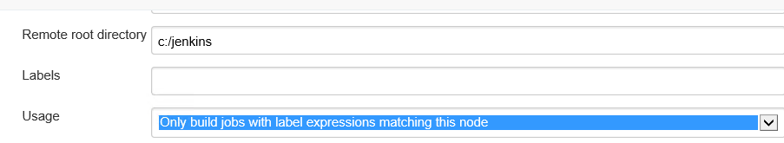

1. Click on save
2. Now goto your job configurations and select “Restrict where this project can be run”
3. And select you node (which we dedicated above)

